# IMT Review

# chapter 2 environment

**External Environment**

The major forces outside the organisation that have the potential to significantly influence on the organisation. 外部环境是可能对组织产生重大影响的主要力量。

**Internal Environment**

The general condition that exit within an organisation. 组织内部退出的一般条件。

**Mega-Environment**

The general environment which reflects the macro conditions and trends in the societies within which an organisation operates. 反映组织所处社会的宏观 情况和趋势的一般环境。

It consists of FIVE major dimensions:

**Technological**

*The current state of knowledge regarding the production of products and services.* *关于产品和服务生产的知识的现状。*

*Most organisations can be greatly affected, either positively or negatively by technological progress. 大多数组织都会受到技术进步的巨大影响，无论是积极的还是消极的。*

*In order to remain competitive, organisations must stay abreast of current technological developments that may affect their ability to offer desirable products and services that meet customers’ expectation 为了保持竞争力，组织必须跟上可能影响其提供满足客户期望的理想产品和服务的能力的当前技术发展*

**Economic**

*The economics systems of producing, distributing, and consuming wealth. i.e Capitalist, Socialist, and Communist.* *生产、分配和消费财富的经济系统。我。资本主义、社会主义和共产主义。*

*The general economic health of the region or country in which the organization operates.*

*Key economic indicators such as gross domestic product (GDP), consumer purchasing power, unemployment rate, interest rate etc. 本组织所在区域或国家的总体经济健康状况。*

*Economic trends.* *经济的趋势。*

**Legal-political**

*The legal and political systems within which an organisation must function.* *一个组织必须在其中运作的法律和政治制度。*

*Trends in legislation, court decisions, politics and government regulation are particularly important.* *立法、法院判决、政治和政府管制方面的趋势特别重要。*

*Variety of laws that specifically address the manner which they must function or operate. e.g. OSHA, IATA, Basel III, etc. 各种具体规定它们必须如何运作或运作的法律。例如OSHA、国际航空运输协会、巴塞尔协议III等*

**Sociocultural**

*The attitudes, norms, beliefs, behaviors, lifestyle and associated demographic trends that are characteristic of a given demographic area.* *态度、规范、信仰、行为、 生活方式和相关的人口趋势是特定人口区域的特征。*

*This element is subject to change over time, it is important for managers to monitor trends that might offer new opportunities or pose significant threats.* *这一因素会随着时间的推移而变化，对于管理者来说，监控可能提供新机会或构成重大威胁的趋势非常重要。*

**International**

*The development of countries or regions outside an organisation's home country that have potential to influence the organisation.* *组织所在国以外可能对组织产生影响的国家或地区的发展。*

*International development can greatly affect the ability of an organisation to conduct business abroad and even locally.* *国际发展会极大地影响一个组织在海外甚至本地开展业务的能力。*

**Task Environment**

The external elements with which an organisation interfaces in the course of conducting its business. 组织在开展业务过程中与之交互的外部因素。

The elements comprise of:

**Customers and clients**

*Individuals or organisations that purchase products and / or services.* *购买产品和/或服务的个人或组织。*

*Organisation today build customer relationship and ensure customer satisfaction so that they stay close to a customer to build rapport and receive continuous* buying. 今天的组织建立客户关系，确保客户满意，使他们与客户保持密切的关系，建立融洽的关系，并得到持续的购买.

**Competitors**

*Other organisations that either offer or have a high potential of offering rival products or services.* *其他提供或极有可能提供竞争产品或服务的组织。*

*Organisations need to keep abreast of what their competitors are doing.* *组织需要跟上竞争对手的步伐。*

**Suppliers**

*Are those organisations and individuals that supply the resources (raw materials and supplies) the organisation needs to carry on operations.* *是指提供组织运作所需的资源(原材料和物资)的组织和个人。*

**Labours**

*Consists of those individuals who are potential employee of the organisation.* *包括那些可能成为组织雇员的个人。*

*Labour supply varies from unskilled, semi-skilled and to professional.* *劳动力供应从非熟练、半熟练和专业人员不等。*

**Government agencies**

*Agencies that provide services and monitor compliance with laws and regulations at local state or regional and national levels. i.e. Securities Commission, Malaysia Qualification Agency (MQA), Bank Negara Malaysia (Central Bank of Malaysia), Malaysian Communications and Multimedia Commission (MCMC). 在地方州或区域和国家各级提供服务和监测遵守法律和条例情况的机构。即证券委员会、马来西亚资格局(MQA)、马来西亚央行(马来西亚央行)、马来西亚通信和多媒体委员会(MCMC)。*

Depends largely on the products and services that the organisation offers and on the locations where the organisation conduct its business. 主要取决于组织提供的产品和服务，以及组织开展业务的地点。

# chapter 3 organization structure

**Organization Chart can show:**

The business divided into areas where employees have responsibilities. 业务分为员工负责的领域。

States relationships between staffs e.g. Supervisor, subordinate, peer. 国家职员之间的关系，例如 主管，下属，同行。

Shows the number of people working in the organization.

显示在组织中工作的人数。

Historical record – organization changes makes the chart become out of date. 历史记录 - 组织变更使图表变得过时。

As information to new employees and special group. 作为新员工和特殊群体的信息。

Main lines of communication. 主要沟通渠道。

**Introduction**

A formal pattern of interactions and coordination designed by management to link the tasks of individuals and group in achieving organisational goals

管理层设计的正式交互和协调模式，将个人和团队的任务联系起来，以实现组织目标

A formal framework by which jobs tasks are divided, grouped and coordinated.

一个正式的框架，通过该框架划分，分组和协调工作任务。

When managers develop or change an organisation’s structure thy engage in **Organisational Design**

当管理者发展或改变组织的结构时，您就会参与组织设计

**Organisation Structure consist mainly of:**

The assignment of tasks and responsibilities that define the jobs of individuals and units分配定义个人和单位工作的任务和责任

Clustering individuals - Units - Departments 集中个人-单位-部门

Top to bottom coordination, number of individuals reporting, degree of delegation and authority自上而下的协调，报告的人数，授权程度和权限

Horizontal coordination横向协调



**Span of Control**

Narrow

Closer and more contact with subordinate更亲切，更与下属接触

Tight control and tight supervision严密控制和严密监督

More time for other duties – planning, decision making 更多时间进行其他职责 - 计划，决策

A lot of layers, more positions 层次多，位置多

Wide

Reduced operation and administrative costs降低运营和管理成本

Easier communication更容易沟通

Coordination problems reduced 协调问题减少了

Quicker decision making更快地做出决策

Can cultivate higher motivation level in subordinates可以培养下属更高的动机水平

**Factors affecting Span of Control**

Competence of a manager经理的能力

Complexity of functions功能的复杂性

Similarity of function功能相似

Non-supervisory duties of manager经理的非监督职责

Direction and control needed by subordinates下属需要的方向和控制

Physical proximity / Geographic location物理接近度/地理位置

**Work Specialization**

The degree to which the work necessary to achieve organizational goals is broken down into various jobs.

实现组织目标所需工作的程度被分解为各种工作。

Without some specialization, it would be difficult for the organization to function.没有一些专业化，组织就很难运作。

People have different skills and abilities, they are usually able to carry out work effectively and efficiently if the job required a particular skill or ability they possess.

人们具有不同的技能和能力，如果工作需要他们拥有的特定技能或能力，他们通常能够有效和高效地开展工作。

**Departmentalization**

How jobs/ tasks are divided, grouped and coordinated.如何划分，分组和协调工作/任务。

All departments must understand and ‘pull’ together toward achieving the organizational goals.所有部门都必须理解并“拉”到实现组织目标。

Activities are grouped by functions e.g. Human Resources, Finance, Marketing. 活动按功能分组，例如 人力资源，财务，市场营销。

Names of the departments depend on the type of business the organization is in. 部门的名称取决于组织所处的业务类型。

**The main department designs are by：**

**Functional departmentalization**

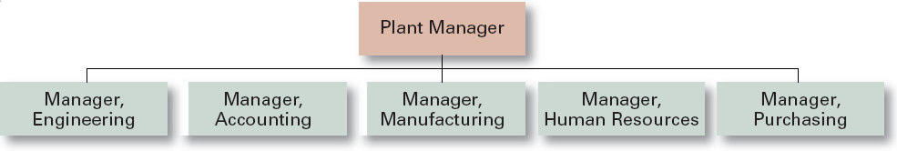

**+** Efficiencies from putting together similar specialties and people with common skills, **+** knowledge, and orientations将类似专业和具有共同技能，知识和方向的人员组合在一起的效率

**+** Coordination within functional area功能区内的协调

**+** In-depth specialization深入专业化

**–** Poor communication across functional areas跨职能领域沟通不畅

**–** Limited view of organizational goals对组织目标的看法有限

**Product Departmentalization**

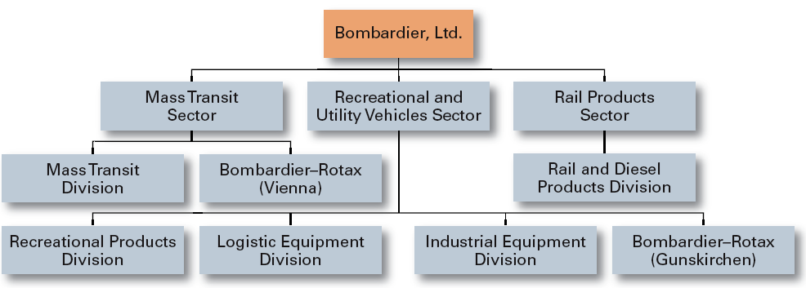

+ Allows specialization in particular products and services+允许特定产品和服务的专业化

+ Managers can become experts in their industry+更贴近客户

+ Closer to customers+经理可以成为他们行业的专家

– Duplication of functions- 功能重复

– Limited view of organizational goals- 对组织目标的看法有限

**Geographical Departmentalization**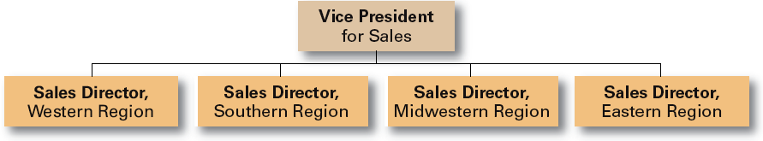

+ More effective and efficient handling of specific regional issues that arise更有效和更有效地处理出现的特定区域问题

+ Serve needs of unique geographic markets better更好地满足独特地域市场的需求

– Duplication of functions重复功能

– Can feel isolated from other organizational areas可以感到与其他组织领域隔离

**Customer Departmentalization**

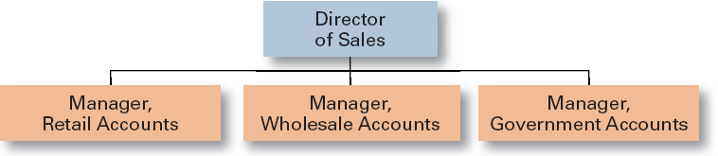

+ Customers’ needs and problems can be met by specialists专家可以满足客户的需求和问题

– Duplication of functions- 功能重复

– Limited view of organizational goals- 对组织目标的看法有限

**Process Departmentalization**

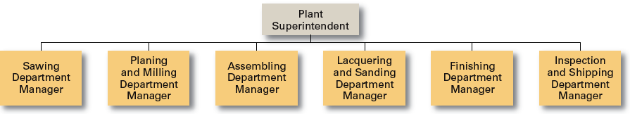

+ More efficient flow of work activities更有效的工作流程

– Can only be used with certain types of products只能用于某些类型的产品

**An Example of a Matrix Organization**

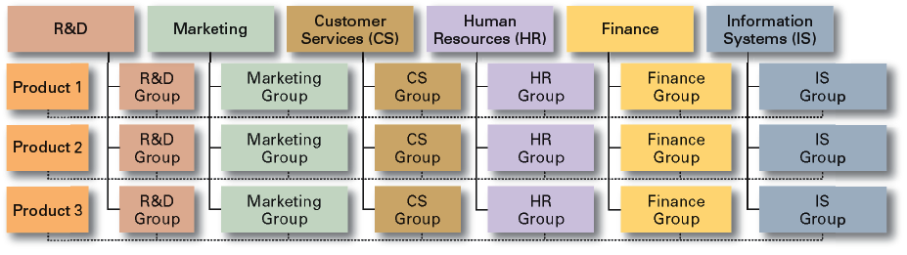

**Organizational Designs**

Matrix and project structures矩阵和项目结构

Specialists from different functional departments are assigned to work on projects led by project managers.来自不同职能部门的专家被分配到项目经理领导的项目上。

Matrix and project participants have two managers.矩阵和项目参与者有两名经理。

In project structures, employees work continuously on projects; moving on to another project as each project is completed. 在项目结构中，员工不断在项目上工作; 每个项目完成后转到另一个项目。

**Chain of Command (COC)指挥链**

Unbroken line of authority forms the top to the bottom of the organization. 不间断的权力形成了组织的最高层。

Everyone is accountable to someone.每个人都对某人负责。

When the COC is too long：

Complexity in communication沟通的复杂性

Message gets distorted消息变形

Depersonalized employee relations非人格化的员工关系

**Definition of terms**

**Responsibility** – Area of work for a person or group is accountable for. E.g. discipline of staff or sales of product. 责任 - 个人或团体的工作领域负责。 例如。 员工纪律或产品销售。

**Duties** – Work or job requirements arising from responsibilities. E.g. Writing a warning letter for late coming or to meet clients or customers to persuade then to buy products or services. 职责 - 责任产生的工作或工作要求。 例如。 写一封警告信，以便迟到或与客户或客户会面，说服他们购买产品或服务

**Authority** – the right to make decisions and take action. E.g. secretary is given the authority to sign orders up to RM500. 权威 - 决策权和采取行动的权利。 例如。 秘书有权签署高达RM500的订单。

**Unity of Command -** The concept that a person should have one boss and should report only to that person. 命令的统一 - 一个人应该有一个老板并且只应该向那个人报告的概念。

**Centralization集权**

Amount of authority delegated to different positions in the organization structure.授权给组织结构中不同职位的权限。

Decision making is focused at the top of the organization hierarchy and lower level just carry out decisions made. 决策主要集中在组织层次结构的顶层，而较低层次只是执行决策。

Authority and work is little delegated.权威和工作很少被委派。

**Advantages**

Top management is aware of the happenings and overall needs, better control over activities高层管理人员了解事件和总体需求，更好地控制活动

Better standardized procedures and policy更好的标准化程序和政策

Easier to maintain secrecy更容易保密

**Decentralization 非集权**

Decision are made at all management levels.在所有管理层面做出决定。

Lower level management provide input in decision making.较低级别的管理为决策提供投入。

Authority and work is delegated授权和工作

**Advantages**

Reduces work load for Top management减少高层管理人员的工作量

Faster decisions更快的决定

Better decisions更好的决定

Employees learn to make decisions员工学会做出决定

Improves staff morale提高员工士气

Organization becomes flexible组织变得灵活

**Formalization形式化**

**Formalization** refers to how standardized an organization’s jobs are and the extent to which employee behavior is guided by rules and procedures. In highly formalized organizations, there are explicit job descriptions, numerous organizational rules, and clearly defined procedures covering work processes形式化是指组织的工作标准化程度以及员工行为在规则和程序指导下的程度。 在高度正式化的组织中，有明确的职位描述，众多组织规则以及涵盖工作流程的明确程序

Actions which are and not to be done, stated in written policies, rules, procedures书面政策，规则和程序中规定了有关和不应做的行动

Helps with vertical coordination有助于垂直协调

Lecture 5 Planning and Decision Making

A process that managers use to identify and select appropriate goals and courses of action for an organisation. 管理者用来为组织确定和选择适当的目标和行动路线的过程。

Strategy – Cluster of decisions and actions that managers take to help an organisation achieve its goals. 战略——管理者为帮助组织实现目标而采取的决策和行动的集合。

**\*Strategies** are the plans how it will compete successfully, and how it will attract and satisfy its customers in order to achieve its goal*战略是指公司如何成功竞争，如何吸引和满足客户以实现其目标的计划

Planning is a decision making and strategy making process. 规划是一个决策和战略制定的过程。

**Types of planning：**

Top Level Planning / Strategic Planning

*Done by top management由最高管理层完成*

*Long range objectives and policies 长期目标和政策*

Second Level Planning / Tactical Planning

*Carried out by Senior Executives由高级管理人员执行*

*Medium term goals中期目标*

*Function Oriented面向功能的*

Third Level Planning / Operational Planning

*Very short term goals短期目标*

*Individual goals*

**Time Horizons of Plans 计划的时间范围**

Each plan has different time frame, meaning that different plans have different time to be completed; 每个计划有不同的时间框架，这意味着不同的计划有不同的时间来完成;

Long term plans – 5 years

Intermediate term plans – 1-5 years

Short term plans – Less than 1 year

Rolling Plan – is usually updated and amended yearly by taking the environment into account. 轧制计划-通常每年根据环境情况进行更新和修订。

Standing Plan – used where programmed decision making is done. 常备计划-用于程序决策完成的地方。

Single Used Plan – to handle non-programmed decision making and one of a kind situation. 单一使用的计划-处理非程序化的决策和一种情况。

**Importance of Planning**

To get all managers to participate in decision making – appropriate goals and strategies for an organisation. 让所有的经理都参与到决策中来——为组织制定合适的目标和策略。

A sense of direction and purpose for the organisation - goals the organisation is trying to achieve and strategies used. 组织的方向感和目标——组织试图实现的目标和使用的策略。

To coordinate managers of the different functions and divisions of organisation to ensure that there is a pull in the same direction. 协调组织内不同职能及部门的经理，以确保他们有共同的目标。

To control managers within an organisation. A good plan specifies goals and strategies and activities the orgnisation has to carry out. 在一个组织内控制经理。一个好的计划规定了组织必须执行的目标、策略和活动。

**Step 1 – Establishment of mission, vision and goals**

Mission – basic purpose and values of the organisation.

Vision – provides a perspective on the direction of the organisation. E.g. Shell – becoming the premier U.S. company.

Strategic Goals – evolve around from the mission and vision.

**Step 2: Analysis of external Opportunities and threats**

Industry and market analysis，Competitor analysis，Political and regulatory analysis，Social analysis，Human Resource analysis，Macroeconomic analysis，Technological analysis行业和市场分析、竞争对手分析、政治和监管分析、社会分析、人力资源分析、宏观经济分析、技术分析

**Step 3: Analysis of internal strengths and weaknesses**

Financial analysis，Human resource assessment，Marketing audit，Operations analysis，Purchasing，Management of information systems财务分析、人力资源评估、营销审计、业务分析、采购、管理的信息系统

**Step 4: SWOT analysis and strategy formulation (I)**

SWOT analysis – a comparison of strengths, weakness, opportunities and threats that help formulate strategy. SWOT分析-比较优势，劣势，机会和威胁，帮助制定战略。

Corporate strategies企业战略

*\*\*Corporate Strategy - This strategy determines what businesses a company is in or wants to be in. It also helps top managers decide what to do with the businesses: grow them, keep them the same, or renew them. 这个战略决定了一个公司所处或想要从事的业务。它还能帮助高层管理人员决定如何处理这些业务:增长业务、保持业务不变或更新业务。*

**Step 4: SWOT analysis and strategy formulation (II)**

Concentration strategy – focuses on a single business competing in a single industry集中战略-专注于单一行业中的单一业务竞争

Vertical Integration – the acquisition or development of parts or components of the organisation’s product (becoming supplier / distributor) 垂直整合-采购或发展机构产品的零件或组件(成为供应商/分销商)

An example would be a supermarket firm that, instead of contracting with freight companies, purchases its own trucks and distribution facilities that it uses to get food items and household products out to its various locations. 一个例子是一家超市公司，它不与货运公司签订合同，而是购买自己的卡车和配送设施，用这些设备将食品和家庭用品运送到不同的地点。

Horizontal intergration –a company grows by combining with competitor横向整合——公司通过与竞争对手的结合而成长

Conglomerate diversification – expanding into unrelated business集团多元化-扩展到不相关的业务

**Step 5: Strategy Implementation**

Ensure new strategies are implemented effectively and efficiently. 确保新策略的有效实施。

Adopt a more comprehensive view of implementation. 采用更全面的实施观点。

Strategies must be supported by appropriate organisation structure, technology, human resource, reward systems, culture etc. 战略必须得到适当的组织结构、技术、人力资源、奖励制度和文化等的支持。

**Step 6: strategic control**

To support managers in evaluating the organisation’s progress with its strategy and in taking corrective actions. E.g. Budget monitoring

协助管理人员评估本组织的策略进展及采取纠正措施。如预算监督

**Obstacles to Effective Planning有效规划的障碍**

Lack of top management involvement and support. 缺乏高层管理人员的参与和支持。

Lack of cooperation from various operating units. 缺乏各经营单位的合作。

Difficult to forecast and set goals. 很难预测和设定目标。

Inconsistency in follow up. 后续工作不一致。

Depending on planning as a ‘quick fix’. 依赖计划作为“快速修复”。

Resistance to change. 变革的阻力。

**Decision Making**

Programmed decision – Decisions made in routine, repetitive, well-structured situations through the use of predetermined decision rules. 程序化决策——通过使用预先确定的决策规则，在常规、重复、结构良好的情况下做出的决策。

Non programmed decision – Decisions for which predetermined decision rules are impractical because the situations re novel and /unstructured 非程序化决策-由于情况新颖和/非结构化，预先确定的决策规则不切实际的决策

**Steps in effective Decision Making**

**Identifying the problem**

Scanning，Categorizing ，Diagnosis扫描、分类、诊断

**Generating Alternative Solutions**

**Evaluating and Choosing and Alternative**

Feasibility，Quality，Acceptability，Costs，Reversibility可行性、质量、可接受性、成本、可逆性

# Lecture 6 Management & Motivation

**Motivation 动机**

Motivation refers to the forces within a person that affect his or her **DIRECTION**, **INTENSITY** and **PERSISTENCE** of voluntary behaviour动机是指一个人内在的力量，它影响着他或她的方向、强度和自愿行为的持久性

(McShane and Von Glinow, 2003)

According to McShane and Von Glinow (2003), motivated employees are willing to exert 根据McShane和Von Glinow(2003)的研究，有积极性的员工愿意努力工作

a particular level of effort (intensity), 努力的程度(强度)，

for a certain amount of time (persistence), 在一定的时间内(持久性)，

toward a particular goal (direction) 朝着一个特定的目标(方向)

**Motivating employees has become very challenging because:**

Organisations change the jobs that people perform 组织改变人们的工作

Organisations reduce layers of hierarchy Organisations 组织减少层级组织

Employee needs are changing 员工需求在变化

**Organisations must motivate people to：**

Join the organisation加入该组织

Remain in the organisation留在组织内

Come to work regularly定期来上班

Achieve high output实现高产量

Exhibit good citizenship表现出良好的公民

Management play a critical role in motivating the workforce管理在激励员工方面起着关键作用

Thus, it is important for the management to ascertain what are the factors that motivate the workforce and focus on those factors因此，对于管理层来说，确定是什么因素激励了员工并关注这些因素是很重要的

**eg:

**Maslow’s needs hierarchy**

People try to satisfy a higher need when a lower need is fulfilled (satisfaction-progression) 当一个较低的需求得到满足时，人们就会试图去满足更高的需求。



**Herzberg’s motivator-hygiene theory**

Motivators (job content, recognition) motivate and satisfy, whereas hygiene factors (work relations, work environment) can create or reduce dissatisfaction but do not motivate激励因素(工作内容、认可)激励和满足，而卫生因素(工作关系、工作环境)可以产生或减少不满，但不能激励

**Herzberg’s Two factor Theory**



**McClelland’s learned needs theory**

Some needs are learned rather than instinctive, and more than one needs can motivate at the same time 有些需求是后天习得的，而不是本能的，而且不止一种需求可以同时激发

Needs acquired or learned on the basis of our life experiences根据我们的生活经验获得或学习的需要

**Three needs was studied：**

Need for achievement (nAch)

The desire to accomplish challenging tasks and achieve a standard of excellence in one’s work渴望完成具有挑战性的任务并在工作中达到卓越的标准

Need for affiliation（联系）(nAff)

The desire to maintain warm friendly relationships with others渴望与他人保持温暖友好的关系

Need for power (nPow)

The desire to influence others and control one’s environment影响他人和控制环境的欲望

**Expectancy theory期望理论**

Motivation is determined by perceived expectancies, outcome values, and a rational decision-making process动机是由感知的期望、结果值和理性决策过程决定的



# Lecture 7 Leadership

**Sources of Leader Power领导权力来源**

**Legitimate Power** - Comes from position’s placement in the managerial hierarchy and authority in a position. 合法权力——来源于职位在管理层级中的位置和职位中的权力。

**Reward Power**- Capacity to control and provide valued rewards 奖励能力-控制和提供有价值的奖励的能力

**Coercive Power** - Ability to punish , when desired behaviour is not seen. 强制权力-在没有看到期望的行为时进行惩罚的能力。

**Expert Power** – Based on possessed expertise that is valued by others专家权力-基于拥有的被他人重视的专业知识

**Information Power** – Access to and control over the distribution of important information about the organisation信息权力——获取和控制有关组织的重要信息的分发

**Reference Power** – Results from being admired or linked by others参考力量——来自于被他人崇拜或联系

**Leadership Traits 特性**

Traits – Distinctive internal qualities or characteristics of an individual. Such as physical characteristics, personal characteristics, skills and abilities, and social factors. 特征-个人独特的内在品质或特征。例如身体特征，个人特征，技能和能力，以及社会因素。

Height, weight, appearance, energy, dominance, originality, intelligence, knowledge, technical competence, interpersonal skills, sociability etc. 身高、体重、相貌、精力、优势、独创性、智力、知识、技术能力、人际关系技巧、社交能力等。

**Behavioral Theories ：行为理论：**

**Iowa Studies爱荷华研究**

**Autocratic独裁** – Leaders make unilateral decision decisions, dictate work methods, limit worker knowledge about goals to just the next step to e performed, and sometimes give feedback that is punitive. 领导者做出单方面的决定，规定工作方法，将员工对目标的了解限制在完成任务的下一步，有时还会给出惩罚性的反馈。

**Democratic民主** – Leader tends to involve the group in decision making, let the group determine work methods, make overall goals known, and use feedback as an opportunity for helpful coaching . 民主领导倾向于让团队参与决策，让团队来决定工作方法，让团队知道整体目标，并将反馈作为帮助指导的机会。

**Laissez-faire 自由放任**– Leaders give the group complete freedom, provide necessary materials, participate only to answer questions, and avoid giving feedback.领导者给予团队完全的自由，提供必要的材料，只参与回答问题，避免给予反馈。

***University of Michigan Studies*** - identified two dimensions of leadership密歇根大学的研究——确定了领导力的两个维度

***employee oriented*** 员工导向- emphasized interpersonal relationships强调人际关系

accepts individual differences among subordinates接受下属之间的个体差异

associated with high group productivity具有较高的团队工作效率

***production oriented*** 以生产为导向- emphasized the technical or task aspects of the job强调工作的技术或任务方面

concerned with accomplishing the group’s tasks关心完成小组的任务

associated with low group productivity and low job satisfaction与团队工作效率低和工作满意度低有关

**Situational Leadership Theory**情境领导理论

-By Hersey and Blanchard -赫西和布兰查德著

Leaders need to alter their behaviors depending on one major situational factor – the readiness of followers. 领导者需要根据一个主要的情境因素——追随者的意愿来改变他们的行为。

Task behavior 任务行为leaders tell people what, how, when, where and who to do tasks领导者告诉人们做什么，怎么做，什么时候，在哪里和谁做任务

Relationship Behavior 关系行为two-way or multiway communication. 双向或多路通信。

**Transformational Leadership变革型领导**

Transactional Leaders 变革型领导– motivate subordinates to perform at expected levels by helping them recognize task responsibilities, identify goals, acquire confidence about meeting desired performance levels, and understand how their needs and the rewards that they desire are linked to goal achievement. 通过帮助下属认识到任务责任、确定目标、获得满足预期绩效水平的信心，以及了解他们的需求和渴望的奖励与目标实现之间的联系，来激励他们在预期水平上完成工作。

Transformational Leaders 转型领导人– motivate individuals to perform beyond normal expectations by inspiring subordinates to focus on broader missions that transcend their own immediate self-interests, to concentrate on intrinsic higher-level goals rather than extrinsic lower level goals, and to have confidence in their abilities to achieve the extraordinary missions articulated by the leader. 激励个人执行超出正常预期激励下属关注更广泛的任务,超越自己的直接利益,关注内在更高层次的目标,而不是外在的低水平的目标,并对自己的能力有信心达到非凡的任务铰接的领袖。

# Lecture 9 Control

**Control**

The process of regulating organisational activities so that actual performance conforms to expected organisational standards and goals. 调整组织活动的过程，使实际表现符合预期的组织标准和目标。

(Matrin and Bartol, 1998)

**Monitor activities** to ensure that they are being accomplished as planned and correct any significant deviation. 监控活动以确保其按计划完成并纠正任何重大偏差。

**Managers must monitor and evaluate: 管理人员必须监测和评价:**

Is the firm efficiently converting inputs into outputs? 公司是否有效地将投入转化为产出?

Are units of inputs and outputs measured accurately? 输入和输出的单位是否准确测量?

Is product quality improving? 产品质量提高了吗?

Is the firm’s quality competitive with other firms? 这家公司的质量与其他公司有竞争力吗?

Are employees responsive to customers? 员工是否对客户负责?

Are customers satisfied with the services offered? 顾客对所提供的服务满意吗?

Are our managers innovative in outlook? 我们的管理人员在展望方面是否具有创新性?

Does the control system encourage risk-taking? 控制系统鼓励冒险吗?

**Significance of Control Process**

Controlling supports the organsing and leading functions by helping ensure that resources are channeled toward organisational objectives. 通过帮助确保资源流向组织目标，控制支持组织和领导职能。

Reduce errors，Reduce wastage，Save time

**Role of Control**

Coping with uncertainty – Dynamic environment, able to monitor specific activities应对不确定性-动态环境，能够监控具体活动

Detecting Irregularities – i.e. poor quality, cost overruns or rising personnel turnover发现不正常情况，例如质量差、成本超支或人员流失率上升

Identifying opportunities 识别机会

Handling complex situation – keep track of various major elements to be sure that they are well synchronized. 处理复杂情况——跟踪各种主要元素，确保它们是同步的。

Decentralizing Authority- at the same time know what’s going on去中心化的权威——同时知道发生了什么

**Levels of Control**

**Strategic Control**

Involves monitoring critical environmental to uncover events that may significantly affect the course of organisational strategic plans, assessing the effects or organisational strategic actions and to ensure that strategic plans are implemented ad intended. 包括监察关键的环境，以发现可能对组织策略计划过程有重大影响的事件，评估其影响或组织策略行动，并确保策略计划得以实施。

For instance: Are we moving in the proper direction? Are our assumptions about major trends and changes correct? Should we adjust or abort the strategy? 例如:我们正朝着正确的方向前进吗?我们对主要趋势和变化的假设正确吗?我们应该调整还是放弃这个策略?

E.g. Semiannual and annual reporting cycles每半年和每一年的报告周期

**Tactical Control战术控制**

Focuses on assessing the implementation of tactical plans at departmental levels, monitoring associated periodic results and taking corrective actions. 重点评估部门战略计划的执行情况，监控相关的定期结果并采取纠正措施。

E.g. monthly and weekly reporting cycles, operating budgets. 例如每月和每周的报告周期，运营预算。

**Operational Control操作控制**

regulates the day-to-day output relative to schedules, specifications, and costs. It is aimed at the allocation and use of resources through an evaluation of the performance of the organisational units in meeting short-term objectives, providing post-action evaluation and control over short periods. 根据计划、规格和成本来管理日常的输出。它的目的是通过评价各组织单位在实现短期目标方面的业绩来分配和使用资源，在短期内提供行动后评价和控制。

For instance: Are product and service output high quality and delivered on time? Are inventories of raw materials, goods-in-process, and finished products being purchased and produced in the desired quantities? 例如:产品和服务的输出质量高，按时交付吗?采购和生产的原材料、半成品和成品的库存是否达到了要求的数量?

**Types of control**

**Feedforward Control** – The regulations of inputs to ensure that they meet the standards necessary for the transformational process. 前馈控制—输入的规则，以确保它们满足转换过程所需的标准。

E.g. selecting and training employees

**Concurrent Control** – the regulation of ongoing activities that are part of the transformation process to ensure that they conform to organisational standards. 并行控制——对正在进行的活动进行管理，这些活动是转换过程的一部分，以确保它们符合组织标准。

**Feedback control** – regulation exercised after a product or service has been completed to ensure that the final output meets organistional standards. 反馈控制-在产品或服务完成后实施的规定，以确保最终的输出符合组织标准。

# Lecture 11 Communication

**Business Communication**

The exchange of messages between people for the purpose of achieving common meanings. 为了达到共同的目的而在人们之间交换信息。

**Types of Communication**

**Verbal communication 语言交流**

Written communication

Oral communication口头交流

**Non-verbal communication**

Body language, Facial expression, eye movements, posture, gestures肢体语言，面部表情，眼球运动，姿势，手势

Proximity and space

*Personal – 18 inches to 4 fee***t** – For friends and informal conversation

*Social – 4 to 12 feet* – An area for formal conversation and business transactions

*Public – beyond 12 feet*

Tone of voice, voice quality, laughing, yawn 声调，音质，笑，打哈欠

Touch (Women tend to use touch to convey care, concern, and nurturance. Men, on the other hand, are more likely to use touch to assert power or control over others). 触摸(女人倾向于用触摸来传达关心、关心和教养。另一方面，男性则更倾向于通过触摸来维护权力或控制他人。

**Functions of Communication沟通的功能**

To control，To inform，To express emotion来表达情感，To motivate

**Communication Skills**

Listening Skills – the difference between Listening and Hearing

Active Listening

Be prepared，Read up，Concentrate，Keep an open mind，Resist distractions，Be active in Q and A session做好准备,读起来,集中注意力,保持开放的心态,抵制干扰,是活跃在问答环节

**Group Communication Networks**

Y，Wheel，Chain，Circle，All- Channel

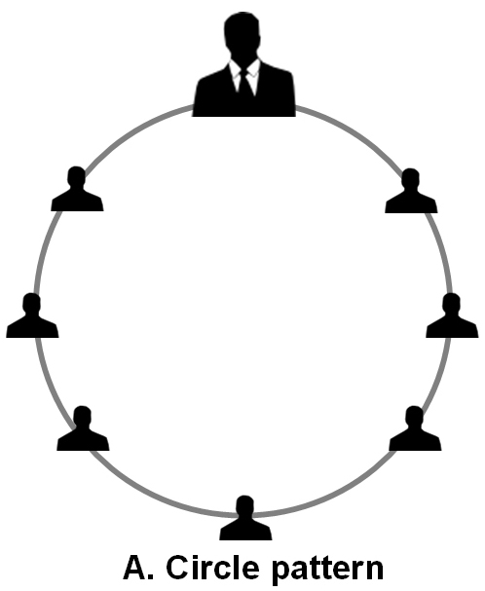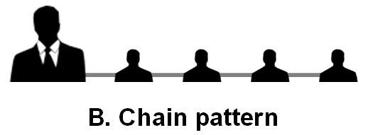

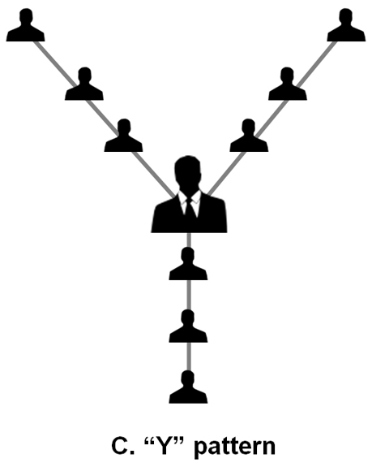 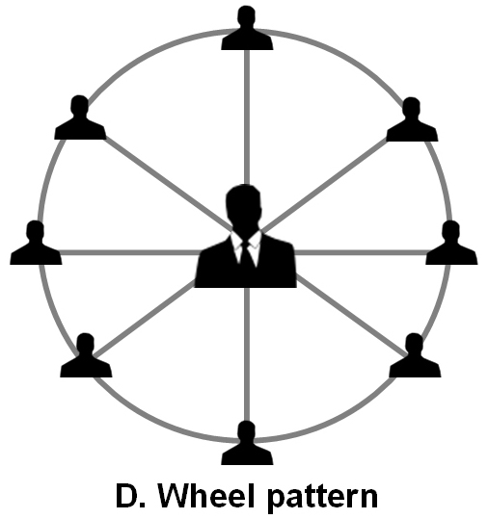

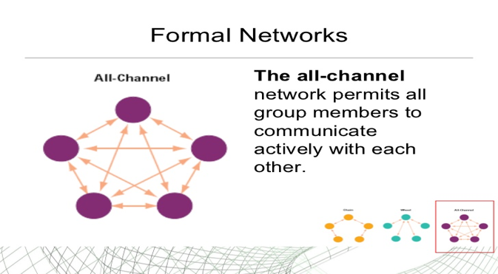

**Communication Channels沟通渠道**

**Horizontal Communication平行沟通**

**Vertical Communication垂直沟通**

Upward，Downward

**Grapevine小道消息**

Single Strand，Gossip，Probability，Cluster单链,八卦,概率,集群

**Electronic to facilitate communications**

E-mail Voice mail语音 Teleconferencing电话会议 Videoconferencing

**Communication Barriers沟通障碍**

Filtering，Selective Perception，Information Overload，Emotion，Language 过滤，选择性感知，信息过载，情感，语言

**Overcome Barriers克服障碍**

Feedback，Simplifying language，Active Listening，Constraining Emotion，Watching for non-verbal cues反馈,简化语言、积极倾听、约束感情,观察非语言线索